Descriptive Research/ Analytical Research/ Meta-analysis
Title of research- must be brief but concisely describes the research

First Author ¹*, Second Author¹, Third Author², Research Adviser²

¹First Affiliation, ²Second Affiliation, The Medical City, Ortigas Avenue, Pasig City
*Put asterisk after the name of the corresponding author; Email address of corresponding author: email@themedicalcity.com

ABSTRACT: Must briefly discuss the research. The abstract shall contain some background information about the research, the main objectives for conducting the study, the main methodology/ technique used, some important results, major discussion point and main conclusion. The abstract shall be a coherently created paragraph and not just a mosaic of parts of the manuscript. There shall be smooth transitions between sentences. There shall be no citations nor figure/ tables referred to in the abstract. The abstract shall not contain more than 250 words.
Keywords: put keywords in alphabetical order; each keyword is separated by a semi-colon; a minimum of three keywords is encouraged

------

ABOUT THE FORMATTING: Please remove this section after editing the manuscript.

Paper Size: Letter Margin: Normal (1’ x 1’) Font: Times New Roman (in most parts)

Font Size: Please follow font size in this document (11 in most parts)

Color: Black (except the top label: Descriptive Research, Analytical Research, etc which is blue)

Indentation: none Alignment: justified throughout

Pagination: at the bottom right

Spacing: Single spacing Spacing before and after paragraphs are 0

2 spaces after each major headings; 1 space after each minor headings (follow example below)

All pages contains continuous line numbers

Main headings are in bold and capitalized like this: INTRODUCTION

Subheadings are in bold but each words are capitalized like this: Population and Sample

Subheadings within subheadings are italicized and in sentence case like this: Inclusion criteria

------

INTRODUCTION
The introduction shall contain the brief background about the study. Citations from related literature can be incorporated in this section. Citation shall be formatted as a superscript after the cited statement as shown here.¹ For multiple citations, use the example here.^{1,2,4-7}
The introduction shall also contain the objectives of the study in a sentence/ statement format (not bulleted), significance of the study, and the scope of the study. The introduction shall be no more than three paragraphs and 400 words.
Introduction should be written in past or present tense but not in future tense.

METHODOLOGY
Population and Sample
Shall include the general description of the population, inclusion and exclusion criteria, Informed Consent process, sampling methods, sampling frame, etc.

Methods (can be subdivided in subsections)
Include the clinical assessments, data collection process, study treatments, study setting, etc. (Fro Meta analysis, these includes search strategy, validation, etc.). Methodology are written in statement form only and not as a recipe type description.
Methodologies are described in detail as much as possible. This section should be written in past tense.

Analysis
Methods of analysis, statistical tools and techniques used, etc.

RESULTS
Results are generally continuous statements without subheadings. Transitions between ideas should be observed.
Include general patient data such as age range, sex, patient selection flow, etc. if applicable
Include major and minor findings.
Results usually contains only a maximum of 2-3 Tables and 2 Figures. You may refer to tables and graphs in this section by citing the table or graph number. For instance, you can see the result of this research in Table 1. Meanwhile some other information is also reported (Figure 1). Table and figure titles, when cited in text, shall be in bold as in the example. Actual tables and figures are not incorporated within the results section (see below).

DISCUSSION
Discussion is never a repetition of what was said in the results section. However, like the results, it is generally continuous statements without subheadings. Transition between ideas shall be observed.
This section shall include the main interpretations of the results, comparison with or support from the existing literature, contribution of the result to the body of knowledge, etc.
Limitations of the study can be also discussed if it is a significant factor in the result gathered.
Conclusion and recommendation shall be given at the end of this section.
For a more structured discussion, the eight-paragraph rule can be followed which contains the following: (1st paragraph)- Major findings, (2)- Interpretation of the findings, (3-5)- Supporting/ contradictory literatures and studies, (6)- Limitations of the study, (7)- Future steps of the research, (8)- Conclusions and recommendations.

ACKNOWLEDGEMENT
Acknowledge the people and institutions directly involved in the conduct and support for the study. Please refrain from thanking God or any other supernatural beings, your pet, your parents (unless they are involved in the financial aspects of the study) or any other entities not directly involved in the research.

REFERENCES
[1] References shall be listed based on the order they were cited in the actual body of the manuscript (not in alphabetical order.
[2] References shall be formatted like this example (tabbed to 0.5’, not hanging indented; numbers before the references corresponds to the number assigned to it during citation; numbers are surrounded by brackets.
[3] Ideally, only journal articles are to be accepted as reference. However, books and hospital files can also be used as long as it is cited properly.
[4] This is how to cite journal articles:
[5] Destura RV, Carascal MB, Regaliza MTP. Title of the article in sentence case. Title of Journal Capitilize Each Words, Volume Number(Series/ Issue Number): Page Numbers- Page Numbers.
[6] This is how to cite books:
[7] Destura RV, Carascal MB, Regaliza MTP. Title of book chapter/s in sentence case. Title of Book Capitilize Each Words. Country of Publisher: Publishing House.

LIST OF TABLES

Table 1. All tables should be found after the references section. Titles of the table should be placed at the top. Tables should not have any vertical lines. Table content should be brief but exact to the point and easy to understand. Abbreviations, footnotes and other details should be placed at the bottom of the table in font size of 8. The title and content should be in 9-pt font size.
Table Title | Content
Table 1 ^{a,b} | The table required for this sample
Table 2 | The table required for this sample
Table 3 | The table required for this sample
- this refers to the notes for a specific item in the table
- this refers to the notes for a specific item in the table

LIST OF FIGURES

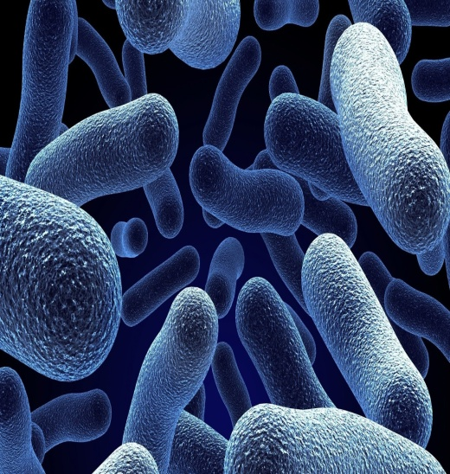
A
B
Figure 1. All figures should be found after the tables section. Titles of the figures should be placed at the bottom with a 10-pt font size. It should be brief and informative. Related or collage of figures should be labeled with A, B, C, etc. This should be described in the title of the figure. Structures/ items/ part of the photo that should be emphasized can be pointed using an arrow. Pictures should be of high quality while graphs should be in scalable vector format.

